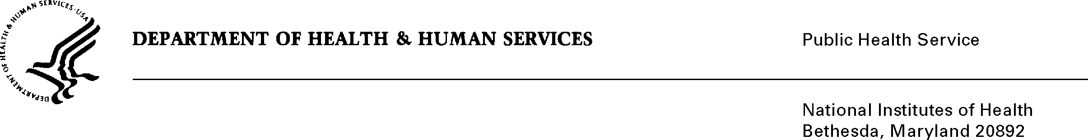
Lung and Upper Aerodigestive Cancer Research Group
Division of Cancer Prevention, NCI, NIH
9609 Medical Center Drive, Room 5E-102, MSC 9781
Bethesda, MD 20892-9781
(240) 276-7011 FAX (240) 276-7848
E-mail: szaboe@mail.nih.gov

March 25, 2021

Re: Cancer Prevention Clinical Trials Network (CP-CTNet)

To Whom It May Concern:

The National Cancer Institute Division of Cancer Prevention (NCI DCP) has established the Cancer Prevention Clinical Trials Network (CP-CTNet) as a grant-funded program functioning under NIH multi-institutional clinical trial guidelines and federal regulations for single IRBs. As such, CP-CTNet clinical trials fall under the purview of the NCI Central Institutional Review Board (CIRB), which is the IRB of record for NCI-sponsored US-based trials and is the only entity authorized to change the protocol. The review of protocols by the local IRBs should be limited to acknowledgement and local oversight.

If additional information is needed, please contact me directly.

Eva Szabo, MD
Director
Cancer Prevention Clinical Trials Networks (CP-CTNet)

